NO PHOTO

Detonics D/A 9mm / .45 ACP
Ammo | Mag | Rng | ROF | Dam | Arm
9mm P  .45 ACP | 7  5 | 10  8 | 2  2 | 1  2 | x2  x3
Detonics D/A 9mm: An American design, the Detonics Super Combat is intended to be used as a backup or holdout gun. The 9mm Parabellum and .45 ACP cartridges are used since they have more punch than the .380 ACP.
Nation: United States Weight: .616 kg
Ammunition: 9mm P, .45 ACP Magazine: 7 / 5
Price: $465 Availability: ( R/- )

NO PHOTO

Detonics Scoremaster
Ammo | Mag | Rng | ROF | Dam | Arm
.45 ACP | 8 | 15 | 2 | 2 | x3
Detonics Scoremater: A heavy pistol designed primarily for target shooting, hence the increased range.
Nation: United States Weight: 1.15 kg
Ammunition: .45 ACP Magazine: 8
Price: $1000 Availability: ( R/- )

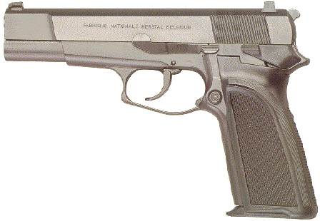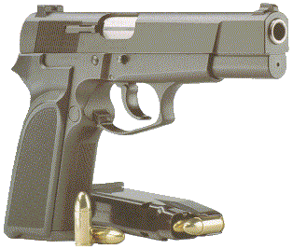
FN BDA9
Ammo | Mag | Rng | ROF | Dam | Arm
9mm P | 14 | 15 | 2 | 1 | x2
FN BDA9: double/single action, high-capacity, semi-automatic pistol that operates by a conventional and reliable short recoil of the barrel. It uses a classic double action trigger which cocks and then releases the hammer. The recoil of the slide recocks the hammer, and all consecutive shots are fired from the single action mode.
Nation: Belgium Weight: 1.04 kg
Ammunition: 9mm P Magazine: 14
Price: $700 Availability: ( R/S )

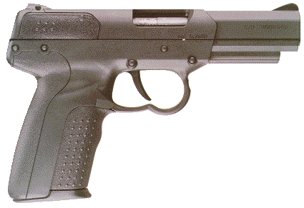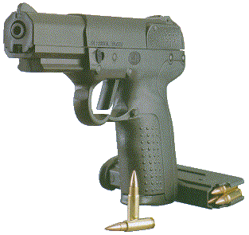
FN Five-seveN
Ammo | Mag | Rng | ROF | Dam | Arm
5.7mm | 20 | 15 | 3 | 0 | ½
FN Five-seveN: A bold venture by FN. The Belgium combat / anti-terrorist Five-seveN fires the 5.7x28mm SS190 Ball round (also used in the FN P-90) which reliably penetrates Kevlar helmets and vests. Many gun enthusiasts have called the Five-seveN “Even Steven”, because for every plus it has, there is a minus. The weapon is has a high reliability and requires limited maintenance. It is light weight, easy to conceal and has a high capacity magazine. The 5.7mm round can penetrate armor but it loses velocity quickly and has little (many argue it doesn’t have any at all) knockdown power. (Referees are encouraged to keep this in mind when rolling for stature checks to remain standing for individuals hit by this round.) The ammunition is almost non-existent and characters using this weapon are encouraged to save casings to make reloads.
Nation: Belgium Weight: .62 kg
Ammunition: 5.7mm Magazine: 20
Price: $1500 Availability: ( -/- )

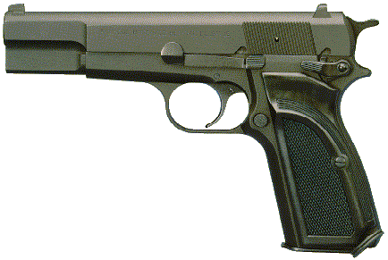
FN MK-3
Ammo | Mag | Rng | ROF | Dam | Arm
9mm P | 13 | 15 | 2 | 1 | x2
FN MK-3: The world's most famous military handgun has been improved. In the early twenties, John Moses Browning and FN Herstal jointly designed the original Browning 9mm Hi Power single action pistol. The MK3 retains the Hi Power's original mechanism as well as all of the major parts and vital advantages of its venerable predecessor. This precludes any deviation whatsoever from the Hi Power's long-standing reputation for safety and reliability under even the most adverse conditions. The MK3's sturdy and simple mechanism also ensures long component life and simple maintenance.
Nation: Belgium Weight: 1.05 kg
Ammunition: 9mm P Magazine: 13
Price: $800 Availability: ( -/R )

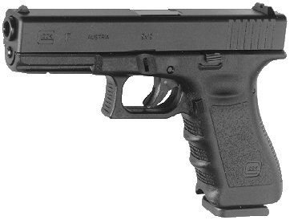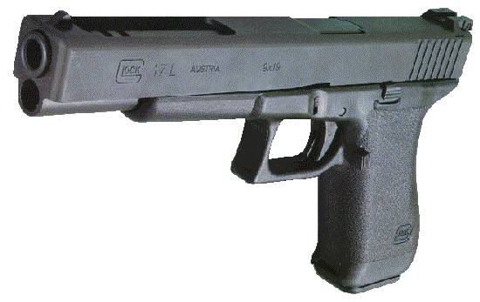
Glock 17
Ammo | Mag | Rng | ROF | Dam | Arm
9mm P  Compact  Longslide | 17  12  17 | 15  12  18 | 2  2  2 | 1  1  1 | x2  x2  x2
Glock 17: . The Glock pistol represents an entirely new era in small arms technology. Currently in service only with the Austrian Army, the Glock has proven to be a reliable weapon on the battlefield. Ease of care and few moving parts make it reliable. The unique plastic frame keep the weapon from dents, dings, rust and corrosion other metal weapons inherit on the field of battle. The 17 comes in the standard version, a compact version (not shown) as well as a Longslide (shown on right)
Nation: Austria Weight: .62 kg
Ammunition: 9mm P Magazine: 17
Price: $800 Availability: ( C/C )

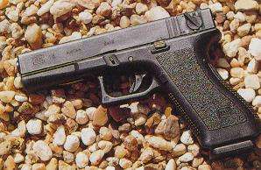
Glock 18
Ammo | Mag | Rng | ROF | Dam | Arm
9mm P  Full Auto | 17  17 / 25 | 15  10 | 2  5 | 1  1 | x2  x2
Glock 18: Similar to the Glock 17, the 18 differs in the fact that it is capable of Full-Auto fire. It has become as the Micro-Uzi, used by body guards and Special Operations units. The Glock 18 shares the same advantages of the other Glock pistols regarding maintenance.
Nation: Austria Weight: .62 kg
Ammunition: 9mm P Magazine: 17 / 25
Price: $1500 Availability: ( S/S )

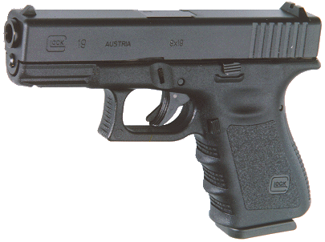
Glock 19
Ammo | Mag | Rng | ROF | Dam | Arm
9mm P | 15 | 15 | 2 | 1 | x2
Description: Glock 17’s little brother. One of the few compacts where the accuracy is virtually unaffected by it’s short barrel.
Nation: Austria Weight: .59 kg
Ammunition: 9mm P Magazine: 15
Price: $650 Availability: ( S/S )
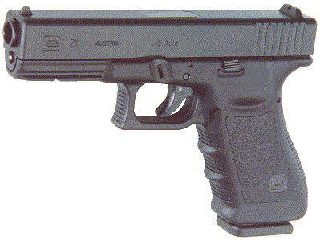
Glock 21
Ammo | Mag | Rng | ROF | Dam | Arm
.45 ACP | 13 | 10 | 2 | 2 | x3
Glock 21: Glock in a .45 ACP. We needn’t say more, but we will. The Glock 21 is a reliable and powerful handgun. Because its frame is make of plastic, the 21 is lighter than its .45 counterparts.
Nation: Austria Weight: ..75 kg
Ammunition: .45 ACP Magazine: 13
Price: $800 Availability: ( C/C )

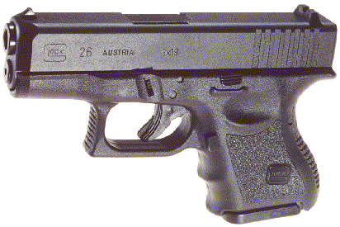
Glock 26
Ammo | Mag | Rng | ROF | Dam | Arm
9mm P | 10 | 10
Glock 26: In July, 1995, Glock introduced the first real innovation in pocket pistols in seventy years - the 9mm Model 26
Though diminutive in size, they're chambered for the venerable 9mm Parabellum. Based on the highly reliable standard Glock design, these little powerhouses offer the best solution to the problems of the pocket pistol. Lightweight, Higher capacity and more accurate than it’s same size rivals.
Nation: Austria Weight: .. .56 kg
Ammunition: .9mm P Magazine: 10
Price: $500 Availability: ( S/S )

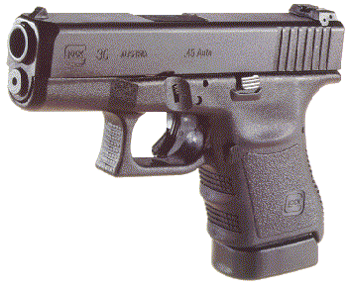
Glock 36
Ammo | Mag | Rng | ROF | Dam | Arm
.45 ACP | 10 | 9 | 2 | 2 | x2
Glock 36: The Glock 36 is a compact .45. Very effective in almost all close combat situations. Easy to handle and control. The short weapon suffers only the slightest fraction of range difference from weapons with larger frames and longer barrels.
Nation: Austria Weight: .. .68 kg
Ammunition: ..45 ACP Magazine: 10
Price: $500 Availability: ( S/S )
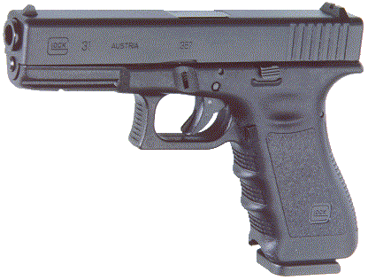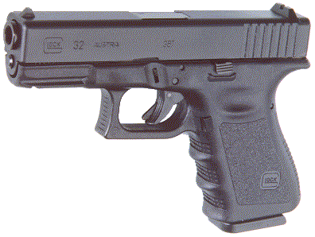
Glock 31 / 32
Ammo | Mag | Rng | ROF | Dam | Arm
.357 SIG | 15 / 13 | 17 | 2 | 2 | x2
Glock 31 / 32: Using the .357 SIG (slightly less powerful than the .357 Automag, the Glocks 31 and 32 are powerful defense weapons.
Nation: Austria Weight: .. 66 kg
Ammunition: .357 SIG Magazine: 15 / 13
Price: $1200 Availability: ( R/R )

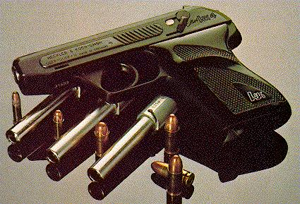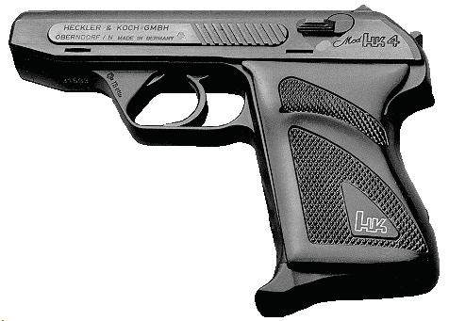
Heckler & Koch HK-4
Ammo | Mag | Rng | ROF | Dam | Arm
.380 ACP  .32 ACP  .25 ACP  .22 LR | 7  8  8  8 | 10  8  16  16 | 2  2  3  3 | 1  1  0  0 | x4  x4  x4  x4
HK-4 (a.k.a. P-11): A small automatic pistol manufactured and sold in four interchangeable barrels (and magazines), enabling the same weapon to be quickly and easily converted from one caliber to another. The HK-4 was the official sidearm of the German border police (called the P-11) until the late 1970s, and was popular with survivalists and weapon fanciers.
Nation: West Germany Weight: .3 kg
Ammunition: .380 ACP/ .32 ACP/ .25 ACP/ .22 LR
Magazine: 7 / 8 / 8 / 8
Price: $600 Availability: ( C/S )

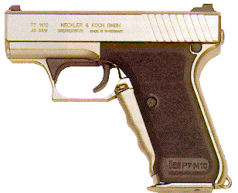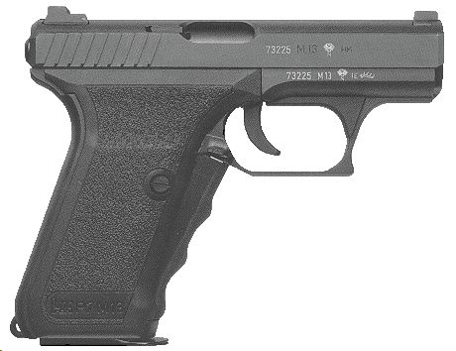
H&K P7 M8 and M13*
Ammo | Mag | Rng | ROF | Dam | Arm
9mm P  9mm P* | 10  15 | 15  15 | 2  2 | 1  1 | x2  x2
H&K P7 (M8 / M13): A West German handgun which has a squeeze-cocking mechanism and can be drawn, cocked, and fired with one motion. This means players do not give up an round of action if their weapon is not already drawn. If their weapon is drawn and ready they get a +2 to their initiative for the first combat round. It cannot fire if dropped or bumped. The M13 is the same as the M8 except for the increased magazine capacity.
Nation: West German Weight: .83 / .95* kg
Ammunition: 9mm P Magazine: 10 / 15*
Price: $600 / $675* Availability: ( C/S )

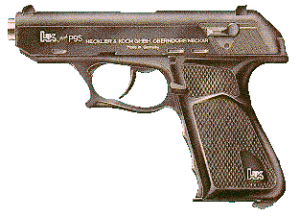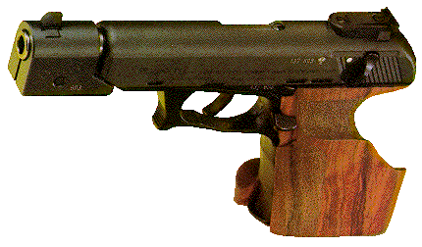
H&K P9S
Ammo | Mag | Rng | ROF | Dam | Arm
.45 ACP | 7 | 12 | 2 | 2 | x3
H&K P9S: A double action semi-automatic pistol made in West Germany, with the same roller-locking feature as the H&K G3 assault rifle series. A cocking lever makes it safe to carry. It is one of the most accurate .45’s made. For this reason it has been used by many as a match pistol.
Nation: West Germany Weight: .88 kg
Ammunition: .45 ACP Magazine: 7
Price: $700 Availability: ( C/S )
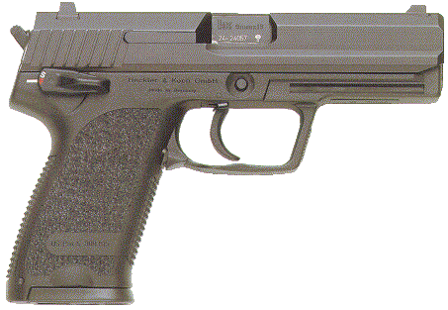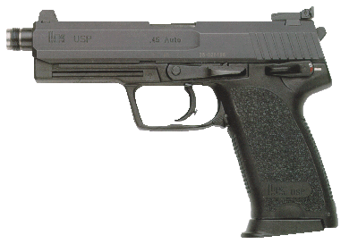
H&K USP 9mm / .45 / .45 Tactical
Ammo | Mag | Rng | ROF | Dam | Arm
9mm P  .45 ACP | 10  10 | 17  12 | 2  2 | 1  2 | x2  x3
HK USP: When Heckler & Koch introduced the USP in 1993, it marked the first time HK chose to incorporate many traditional handgun design elements in one of its pistols. So when HK crossed into the mainstream with the USP, two principles guided its development - the first being the use of advanced materials and engineering technology, the second being the creation of a "pistol paradigm", that is a pistol better than all those existing now or in the past.
Nation: West Germany Weight:
Ammunition: 9mm P / .45 ACP Magazine: 10 / 10
Price: $650 Availability: ( C/S )

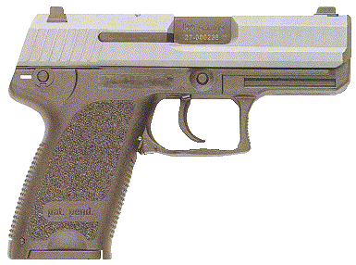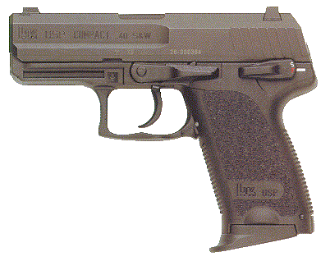
H&K USP Compact
Ammo | Mag | Rng | ROF | Dam | Arm
9mm P  .45 ACP | 13  8 | 13  10 | 2  2 | 1  2 | x2  x3
HK USP Compact: Smaller version of the USP.
Nation: West Germany Weight:
Ammunition: 9mm P / .45 ACP Magazine: 13 / 8
Price: $550 Availability: ( S/S )

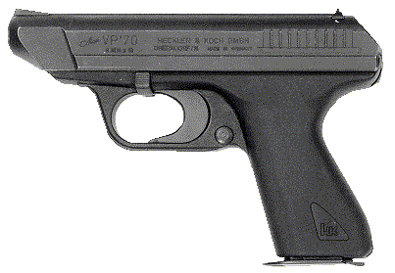
H&K VP70Z
Ammo | Mag | Rng | ROF | Dam | Arm
9mm P | 17 | 15 | 2 / 6 | 1 | x2
H&K VP70Z: This high-magazine-capacity, West German pistol replaced the Walther PPK as the service weapon of the British Secret Service (MI-6) and the Security Service (MI-5). It has been used by the West German Anti-Terrorist Group, GSG-9, favored for its light weight and large magazine capacity. It was designed for automatic fire using a detachable stock.
Nation: West Germany Weight: .78 kg
Ammunition: 9mm P Magazine: 17
Price: $800 Availability: ( S/R )

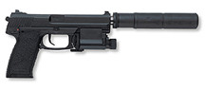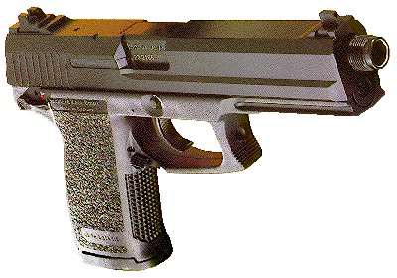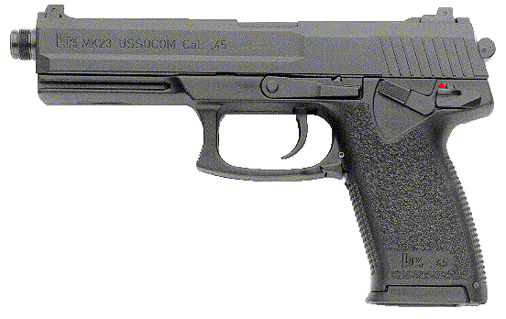
H&K MK 23 / SOCOM
Ammo | Mag | Rng | ROF | Dam | Arm
.45 ACP | 10 / 12 | 15 | 2 | 2 | x3
HK MK 23: The HK MK 23 and the HK Mark 23 .45 ACP pistols give shooters match grade accuracy equal to that of the finest custom made handguns - yet they exceed the most stringent operational requirements ever demanded of a combat handgun. The MK 23/Mark 23 provides this accuracy without the need for hand-fitted parts common in custom-built match pistols costing thousands of dollars more. The HK Mark 23 is a commercial model of the U.S. Government issue MK 23, MOD 0 Offensive Handgun and is available in limited numbers
Nation: West Germany Weight: 1.6 kg
Ammunition: .45 ACP Magazine: 10 / 12
Price: $1700 Availability: ( -/- )

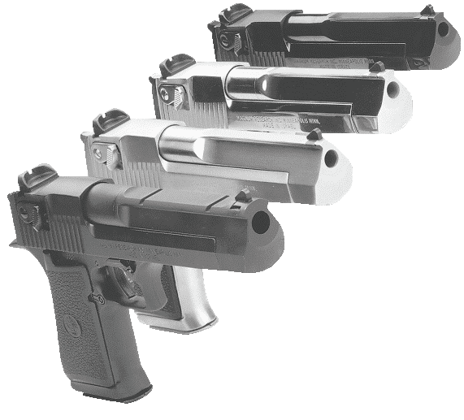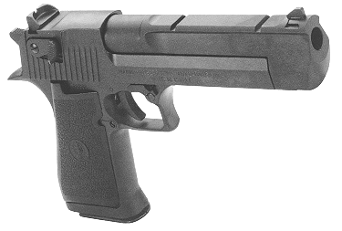
IMI Desert Eagle
Ammo | Mag | Rng | ROF | Dam | Arm
.357 MAG  .44 MAG  .45 ACP  .50 CAL | 9  9  9  7 | 20  18  12  20 | 1  1  2  1 | 3  3  2  4 | x2  x2  x3  -
IMI Desert Eagle: Designed and biult in Isreal, it is a semi-automatic pistol that fires large caliber shells. There are 4 versions in production. The .357, .44, .40 (using .45 ACP for game play), and of course, the infamous .50. Their short length makes them an exception to general rules on .38 special and .357 magnum interchangeability.
Nation: Israel Weight: 1.75 kg
Ammunition: .357 /.44 / .45 /.50 Magazine: 9 / 9 / 9 / 7
Price: $2500 / 3000 / 3000 / 3500 Availability: ( R/- )

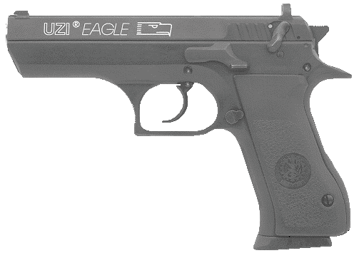
IMI M91

Ammo | Mag | Rng | ROF | Dam | Arm
9mm P | 13 | 15 | 2 | 1 | x2
IMI M91: Designated and built by Israeli Military Industries (IMI), the M91 is based on the popular Desert Eagle handgun series. In 1991, the M91 became the standard issue sidearm for the Israeli Military. It has proven itself to be a rugged and reliable weapon.
Nation: Israel & South Africa Weight: 1 kg
Ammunition: 9mm P Magazine: 13
Price: $850 Availability: ( S/R )

